Task_04

Future of IoT in Smart Cities
A Case Study on How Connected Technology is Shaping Tomorrow's Urban Life

Introduction
Cities have always grown around the same basic problems: how do you move people around efficiently, keep the lights on, manage waste, and keep everyone reasonably safe
all while the population keeps increasing. For a long time, cities dealt with these problems using fixed infrastructure and a lot of manual monitoring. Traffic lights ran on timers regardless of actual traffic. Streetlights stayed on all night whether anyone was outside or not. Waste collection followed a fixed schedule instead of actual need.
The Internet of Things is changing that by giving cities a way to actually sense what's happening in real time and respond to it instead of just guessing. A 'smart city' is basically a city that uses networks of sensors, connected devices, and data platforms to manage things like traffic, energy, water, waste, and public safety more efficiently. This case study looks at where smart city IoT stands right now, what it's actually being used for, the challenges still holding it back, and where the technology seems to be headed over the next several years.

What Makes a City "Smart"?
At its core, a smart city setup follows a pattern that's pretty similar across most IoT systems: sensors collect data from the physical environment (think traffic cameras, air quality sensors, smart meters, parking sensors), that data gets sent over a network to a central platform, and then software increasingly powered by AI analyzes it and either alerts a human or triggers an automatic response. The difference in a smart city is just the scale. Instead of monitoring one home or one factory, the system is monitoring an entire urban area with thousands or even millions of connected points.
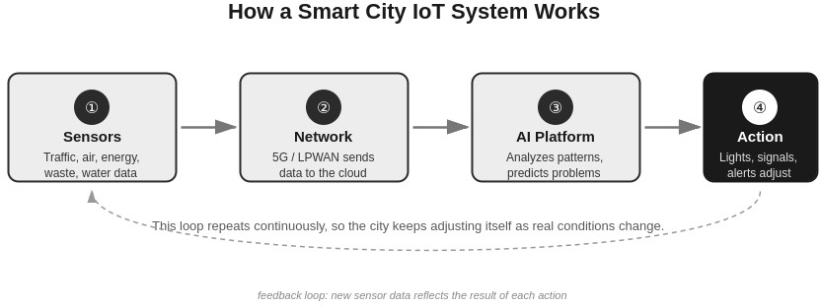

Figure 1: The basic sense → connect → analyze → act loop behind most smart city IoT systems.

Where Smart City IoT Is Already Being Used
Smart city technology isn't really a future concept anymore a lot of it is already running in cities around the world, just at different stages of maturity depending on the city and country. Some of the main areas where it shows up:
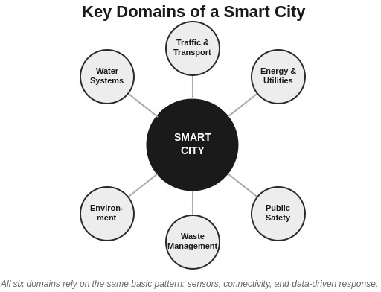
Figure 2: The six domains covered in this case study, all connected back to the same core IoT pattern.

Urban Area | What IoT Does Here | Example
Traffic & Transport | Adjusts signals based on real congestion, tracks public transport live | Smart traffic lights that respond to actual flow, not fixed timers
Energy & Utilities | Balances power load across the grid, detects leaks/faults early | Smart grids and smart meters
Waste Management | Sensors track how full bins are so trucks only go where needed | Smart waste bins in several European cities
Public Safety | Connected cameras and sensors help detect incidents faster | Smart street lighting paired with surveillance
Environment | Tracks air quality, noise, and water levels in real time | Pollution sensors across city districts

Out of all of these, traffic management and energy tend to be the areas where cities see the fastest, most visible return, which is probably why they're usually the first thing a city government invests in when starting a smart city program.

How Big Is This Actually Getting
The growth numbers here are honestly pretty large. Industry reports put the global smart city IoT market at somewhere around $270-330 billion in 2025-2026, and most forecasts expect it to keep growing at over 20% per year for the next several years, possibly crossing $700 billion by around 2030. A big part of that growth is coming from governments directly funding smart city programs, plus rising urban population putting more pressure on existing infrastructure. Asia and parts of the Middle East are investing especially heavily, since several of their cities are essentially being built or rebuilt with smart infrastructure baked in from the start, rather than retrofitted onto old systems.

Where This Is Headed — The Future Part

AI Doing More of the Thinking
The biggest shift happening right now is that smart city systems are moving from just collecting data to actually making decisions with it. Early smart city projects were mostly about putting sensors everywhere and dumping the data into a dashboard for a human to look at. Now, AI models are increasingly doing the analysis themselves predicting where traffic jams are about to happen before they occur, or flagging unusual patterns that might indicate a problem, instead of waiting for a person to notice.

Digital Twins of Whole Cities
One trend that's picking up speed is the idea of a 'digital twin' basically a live virtual model of a city that mirrors what's happening in the real one, fed by all the sensor data coming in. Planners can use this to simulate what would happen if they changed a bus route, added a new building, or rerouted traffic, without actually doing it in real life first. This used to be mostly experimental, but it's becoming a more standard planning tool in larger smart city projects.

5G and Better Connectivity
A smart city with thousands of sensors needs a network that can actually handle that much traffic with low delay, especially for things like traffic systems where a slow response is basically useless. 5G rollout is a major part of what's making denser, more responsive smart city networks possible, since it supports far more connected devices per area than older networks could.

Sustainability Becoming the Main Selling Point
A lot of newer smart city projects are being framed mainly around sustainability reducing energy waste, cutting emissions, and managing resources like water more carefully. Smart grids that balance electricity demand in real time, and sensor networks that catch water leaks early, are good examples of this. As climate concerns grow, this

angle is becoming less of a side benefit and more the main reason cities are investing in this technology at all.

The Challenges That Are Still There
None of this comes without problems, and it's worth being honest about them rather than just listing the upside.
- Cost: Installing sensors, networks, and data platforms across an entire city is expensive, and not every city government has that kind of budget, especially in developing regions.
- Privacy: A city full of cameras and sensors collecting data on how people move and behave raises real concerns about surveillance and how that data gets stored, used, or potentially misused.
- Security: The same issues that affect individual IoT devices weak passwords, outdated firmware, poor encryption apply here too, except a successful attack on city infrastructure (like a traffic system or power grid) can affect far more people at once.
- Old infrastructure: A lot of cities are trying to add smart technology on top of infrastructure that's decades old, which isn't always straightforward or cheap to retrofit.
- Getting different systems to work together: Traffic systems, energy systems, and waste systems are often built by different vendors using different standards, so getting everything to actually talk to each other smoothly is harder than it sounds.

Conclusion
Smart cities are one of the clearest examples of where IoT is genuinely changing how something fundamental — in this case, urban life — actually works, rather than just being a nice-to-have gadget. The shift from fixed, manual city infrastructure to real-time, sensor-driven, increasingly AI-assisted systems is already happening in a lot of major cities, and the growth numbers suggest it's only going to speed up over the next several years. That said, the challenges around cost, privacy, security, and old infrastructure are real and aren't going away on their own. The cities that end up getting the most out of this technology will probably be the ones that take those problems seriously from the start, instead of just focusing on the impressive parts like AI traffic prediction or digital twins.

References
- Research and Markets. (2026). IoT in smart cities market report 2026. researchandmarkets.com/reports/5850526

- Market Research Future. (2026). IoT smart cities market size, share & trends. marketresearchfuture.com/reports/iot-smart-cities-market-26671
- Binariks. (2026). 10 emerging IoT technology trends for 2026 and beyond. binariks.com/blog/iot-technology-trends-and-future
- IoT Insider. (2026). IoT in 2026: The technologies driving the next wave of IoT growth. iotinsider.com/iot-insights
- LogicalWings. (2025). How IoT is driving the growth of smart cities in 2026. logicalwings.com/how-iot-is-driving-the-growth-of-smart-cities-in-2026
- Tblocks. (2026). Latest IoT trends in 2026 shaping connected living. tblocks.com/articles/top-iot-trends

